

November 2013 HSS PTSA Newsletter

  VISIT OUR SITE:  http://southptsa.org/  All forms and upcoming events located on PTSA website  Like us on Facebook:  http://www.facebook.com/WW-P-HS-South-PTSA  In This Issue:  * Principal’s Corner  * PTSA Welcome  Upcoming Events:  * 11/8 – Deadline Reflections program  * 11/13 – HSN Volunteer Fair  Fundraising:  * Just Write A Check (JWAC)  * Clothing Sales  * Target Card Designation  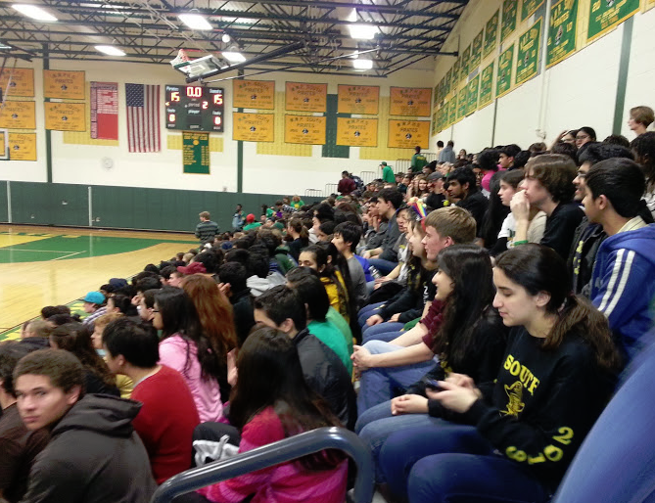  High School South Parent Teacher Student Association  Upcoming General Meetings:  - 1/22/14 – Department Supervisors  - 3/3/14 – Volunteer Fair  - 3/19/14 – SAT Fair  - 5/21/14 – College workshop  Feel free to contact us at southptsa@gmail.com with any comments / concerns and feel free to share the Google southptsa public calendar onto your Google calendar.  Thank you for your continued support, and we look forward to seeing you soon,  Kathy Modi, President  Janet Greenman, VP  Denise Valen, VP  Anjali Sharma, VP  Heather Neilson, Treasurer  Micki Kermani, Secretary | In This Issue:  Principal’s Corner:  Many of you know I have always been a fan of Coach Wooden. The legendary UCLA basketball coach passed a few years ago. Fortunately for us, his wisdom lives on. While at UCLA, Wooden conducted himself as a teacher more than a coach and his court was his classroom where he used his simple, classic approach to teaching and playing. He believed that the little things done correctly made a big difference. He started the first practice of every season instructing his players the correct way to put on their socks and shoes. When asked his reason for doing this. He responded, “Wearing socks improperly leads to blisters and loss of playing time.”  During games he would sit back and watch his team --not yell and scream at his players—just watch because, “It was my job to prepare them for the game. If they did not do something correctly, it was because I did not prepare my players.” How many times have you been at a game and heard coaches or parents yelling instructions at their players or children? I think this has occurred at just about every game I have ever attended from recreation level to varsity level. Could you imagine the impact of our teaching and their learning if we kept quiet during the games? Other than offering encouragement, being quiet provides our children the opportunity to think and perform based on what we have taught them.  This approach to teaching/coaching, and even to parenting, is important because our students, players, and children need to be able to think critically and make good decisions when we are not there. It is amazing to think of John Wooden as “old fashioned” when his values and practices are what is needed most in today’s society and schools: teaching children and students to think for themselves.  To honor Wooden as a coach and a teacher, I would like to share a few of his team rules which I believe are simple statements for us to instill in our children, students, and players.  Be on time. Being on time is just being respectful. It tells everyone else that you value their time as much as you value your own time  Don’t use foul language. This rule does not need any clarification.  Don’t criticize others. Wooden said, “I never permitted a player to criticize a teammate. If I saw a player criticizing a teammate I would, you know, uh, talk to him! I wouldn't permit that. I also insisted that a player never score without acknowledging somebody else. I tried to conduct myself in such a way that I wanted my players to act. I think our youngsters, whether they be basketball players or our children at home, need models more than they need critics.”  Additionally, here are a few rules Wooden’s father shared with him when he was growing up on a farm in southern Indiana.  Don’t whine. Once again, this needs no clarification or further explanation.  Don’t complain. All of us waste too much energy complaining about a situation. This energy channeled in a creative positive way could help solve the problem or at least begin a solution.  Don’t make excuses. I have heard many excuses for everything. The most famous is I or we didn’t have time to do something. When, in reality, we all have 24 hours a day and 7 days in a week. Let’s be honest and say it was not a priority. We chose to use our time to focus on something else.  Go out and do your best. This last statement is all we can ask of ourselves and each other. This rule is especially relevant as we near the end of the marking period. Students overly concerned with a certain letter grade ask teachers to “bump” them to a higher letter grade citing parental pressure or future opportunities. Unfortunately, our compassionate teachers want to help students; however, I have reminded them not to change a grade because doing so makes the grading system arbitrary. Also, I have asked teachers to copy me on their reply to those students who email asking for a “bump,” and to send this simple message:  “You should be proud of the grade you earned. Increasing your grade would be unethical and diminish the efforts of your classmates who earned the higher grade.”  These directions are eloquently simple. However, they are difficult to follow. Yet, if we can follow them and model these behaviors for our students and children, it may be the best teaching we can do. After all, in Wooden’s words, “Our children need models more than they need critics.”  PTSA Welcome:  We want to thank all who helped and attended during the Fall Flea Market, Catalyst Boot Camp, and Back to school Night. PTSA would not be able to continue to support HSS staff and students without the support of our Committee Chairs and volunteers.  Tips for the month:  - Sign up for HSS Google Group via tjones tajones508@gmail.com  - Make sure you are receiving eNews via Guidance department  - Sign up for Twitter emergency text alerts by sending text "follow WWP_Notices" to 40404  - Check out HSSouth’s own Calendar at http://wwphs.sharpschool.com/h_s_s_activities/south_calendar/  Upcoming Events:  Reflections Program  Encourage your High School Students to participate in the REFLECTIONS PROGRAM 2013-2014. The theme this year is “Believe, Dream, Inspire”. Students may submit one or more entries inspired by the above theme in any number of the following categories: Musical, Photography, Literature, Visual Arts, Film/Video and Dance Composition. The form is available on the PTSA website or you may pick up on from the main office. The last day for the submission is Monday, Nov. 18th, 2013.  Questions or assistance with application form?? Please contact your student committee chairs: Isaiah Johnson at ijohn1972@gmail.com, and Saloni Sharma at sharma.saloni10@gmail.com  HSN Volunteer Fair  HSN Sponsored Volunteer Fair is scheduled on November 13th at 7pm in HSN Upper Dinning Hall and is open to all Middle School and High School students.  .  Fundraising:  Just Write A Check:  Consider showing your support for the PTSA by contributing to the “Just Write a Check” program at South. The donation form is on the PTSA website.  Target Card Designation:  HS South participates in Target’s School Fundraising Made Simple Program, which is a terrific fundraiser for us. Simply charge your purchases on your Target Credit Card with HS South designated to receive 1% back. Applications are available at Target stores or go to their website, www.target.com, and click on the guest card icon. Our ID number is 74388. To change your designate, call 1-800-316-6142.

